Project Documentation
Title: Distributed AI Agents for Traffic and Environmental Data Monitoring
Author: Ashutosh Pattanayak

📘 Table of Contents
- Introduction
- Project Objectives
- System Architecture
- Agent Details
- Data Flow & Endpoints
- Code Explanation (with your register_with_consul() code)
- Deployment Guide
- User Guide
- Results & Observations
- Conclusion
- Appendix (code snippets, diagrams)

1. Introduction
This project simulates a distributed system of AI agents that generate synthetic environmental and traffic data, register themselves with Consul for service discovery, and provide data monitoring through a central Flask web-based dashboard.
2. Project Objectives
- Create modular agents generating synthetic data (traffic congestion, CO₂ levels, humidity, temperature, noise)
- Register agents dynamically with Consul
- Build a centralized dashboard to visualize agents’ health, intelligence, requirements, and data
- Enable data export for analysis (JSON/CSV)
3. System Architecture
Architecture Summary:
- Agents (traffic_agent, noiseagent, humidity_agent, temperatureagent) run as separate Flask services inside Docker containers.
- Each agent registers itself with Consul on startup, and can be viewed on localhost:8500
- The controller (dashboard) queries Consul for registered agents and fetches data or health status, and the dashboard of the Flask app can be viewed on localhost:8000
4. Agent Details
Each agent:
- Runs a Flask app on a unique port.
- Exposes endpoints:
  - /health — returns JSON health status
  - /intelligence — capabilities of agents are provided like the average values of co2 emissions, average traffic congestion, average noise levels, average humidity levels and average temperature
  - /requirements – displays data that is required by the user such as for traffic_agent the requirement displayed is average_vehicle_count, and similarly, with other agents
  - /data — latest synthetic reading
  - /data/history – can see the history of data displayed in a Json file
  - /data/export/json and /data/export/csv — historical data export
- Registers with Consul to announce its existence.

5. Data Flow & Endpoints
- Agents register with Consul via /v1/agent/service/register.
- Controller queries Consul for healthy agents.
- Controller calls /health, /intelligence, /data on agents’ port such as port 5001 for co2_agent similarly with others
- Data visualized in the dashboard and available for export.

Example /health response:(Let’s say for traffic_agent can be viewed on localhost:5000/health)
And this is what can be expected as output if agents are live and running{"status": "healthy"}

Example /data response:(Similarly, this is also for traffic_agent and can be viewed on localhost:5000/data since the port it is registered on is 5000)
{
"congestion_status": "Moderate Congestion",
"timestamp": "2025-07-01T19:24:42.697955",
"vehicle_count": 61
}
6. Code Explanation
Agent Registration with Consul:
def register_with_controller():
try:
response = requests.post(CONTROLLER_URL, json=metadata)
if response.status_code == 200:
metadata["uuid"] = response.json().get("uuid")
print(f"[INFO] UUID received from controller: {metadata['uuid']}")
save_metadata()
else:
print(f"[ERROR] Failed to register: {response.text}")
except Exception as e:
print(f"[ERROR] Controller registration failed: {e}")

def register_with_consul():
try:
agent_ip = socket.gethostbyname(socket.gethostname()) # Get container's IP

service = {
"ID": metadata["uuid"],
"Name": metadata["agent_name"],
"Address": agent_ip,
"Port": PORT,
"Meta": {
"sensor_type": metadata["sensor_type"],
"location": metadata["location"],
"unit": metadata["unit"],
"frequency": metadata["frequency"]
},
"Check": {
"HTTP": f"http://{agent_ip}:{5001}/health", # Correct health check URL
"Interval": "10s"
}
}

conn = http.client.HTTPConnection("consul", 8500)
conn.request(
"PUT",
"/v1/agent/service/register",
body=json.dumps(service),
headers={"Content-Type": "application/json"}
)
res = conn.getresponse()
print(f"[INFO] Registered with Consul. Status: {res.status} {res.reason}")
conn.close()

except Exception as e:
print(f"[ERROR] Failed to register with Consul: {e}")

register_with_controller()
Purpose:
Registers the agent with your central controller (your dashboard’s Flask app) so it can recognize the agent, assign it a UUID, and store its metadata.
How it works:
1) Sends an HTTP POST request to CONTROLLER_URL with the agent’s metadata as JSON.
2) Checks if the response status code is 200 (success):
- If successful, it extracts the UUID from the response, saves it into metadata["uuid"], prints confirmation, and saves the updated metadata locally by calling save_metadata().
- If not successful, it prints an error with the response text.
- If any exception occurs (e.g., controller unreachable, network error), it prints a descriptive error message.
What it enables:
- Ensures the controller knows all active agents and assigns them unique UUIDs for tracking.
- Stores important agent info like name, type, location, and more in the controller’s database or memory.

register_with_consul()
Purpose:
Registers the agent with Consul, a service registry, so the controller and other services can discover it dynamically.
How it works:
1) Uses socket.gethostbyname(socket.gethostname()) to get the container’s actual IP address — crucial in Docker because localhost inside a container doesn’t mean the host machine; it points to the container itself. This ensures the health check URL points to the real IP.
2) Builds the service dictionary:
- "ID": the unique UUID from metadata.
- "Name": the agent’s name.
- "Address": the container’s IP address obtained earlier.
- "Port": the agent’s Flask port.
- "Meta": dictionary containing descriptive information about the agent:
  - sensor_type, location, unit, frequency.
- "Check": Consul health check configuration:
  - "HTTP": URL Consul should poll every 10s to verify the agent is healthy (points to /health).
  - "Interval": every 10 seconds.
3) Opens an HTTP connection to Consul running at consul:8500 (the Consul container’s standard hostname in Docker).
4) Sends an HTTP PUT request to /v1/agent/service/register with the service JSON as the request body.
5) Prints registration status code and reason to confirm successful registration.
6) Closes the HTTP connection.
7) If any exception occurs, prints a descriptive error.

Why these functions matter together
- register_with_controller() tells the controller that an agent exists, giving it a UUID and registering metadata for central tracking.
- register_with_consul() tells Consul that the agent is alive, where it can be reached, and how it should be health-checked, enabling dynamic discovery and load balancing.

7. Deployment Guide
Prerequisites:
- Docker & docker-compose installed
Run All Agents and Dashboard:
docker-compose up -d --build
Access Dashboard:
- Central dashboard UI: http://localhost:8000
- Consul UI: http://localhost:8500

8. User Guide
Navigate to the dashboard to:
- View agents and their health status.
- See capabilities and data streams.
- Export data (JSON/CSV) for analysis.
Monitor agents in Consul UI:
- Registered services appear with their health.

9. Results & Observations
- All agents registered successfully with Consul.
- Dashboard shows real-time health and data from each agent.
- Data export tested with accurate JSON/CSV outputs.
- Consul UI displays healthy services for each agent.

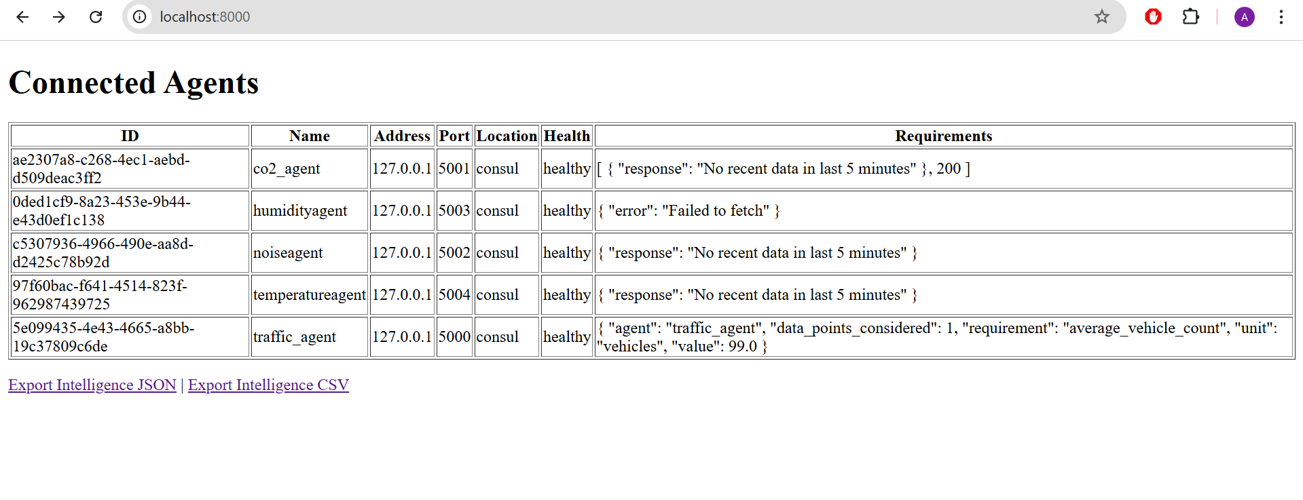
This is the Flask web-based dashboard showing agent health status, and requirements, and intelligence at localhost:8000/requirements and localhost:8000/intelligence respectively

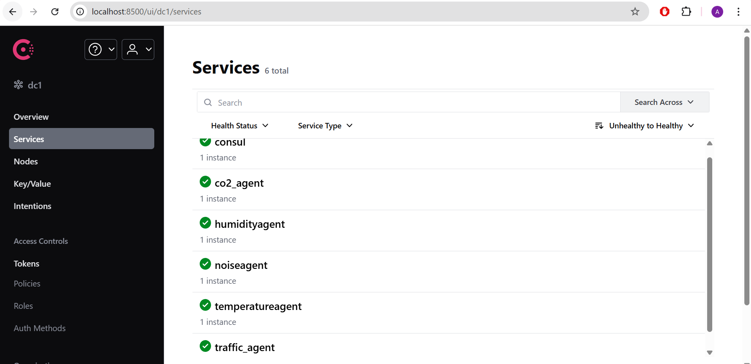

This is the consul interface that is showing the service discovery of all the agents

11. Appendix
Platform for Clustered Edge Intelligence with discoverability and observability capabilities.
Overall Sy.
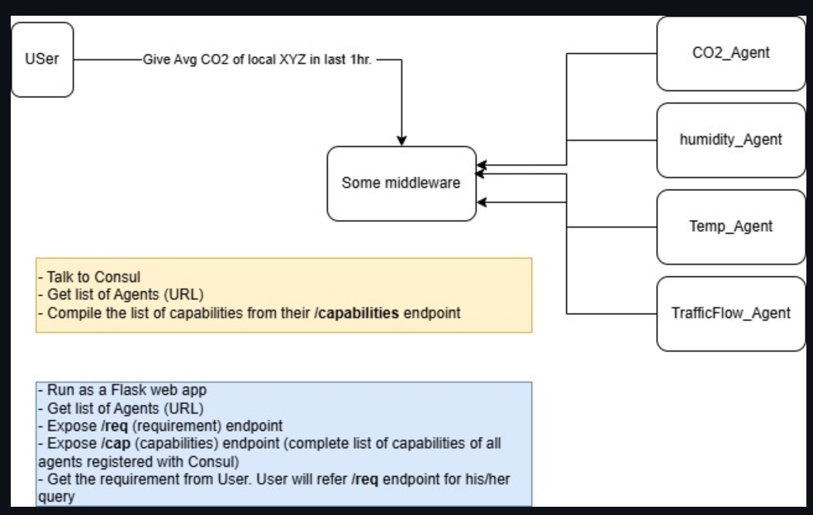

Flash web-based app working module:-
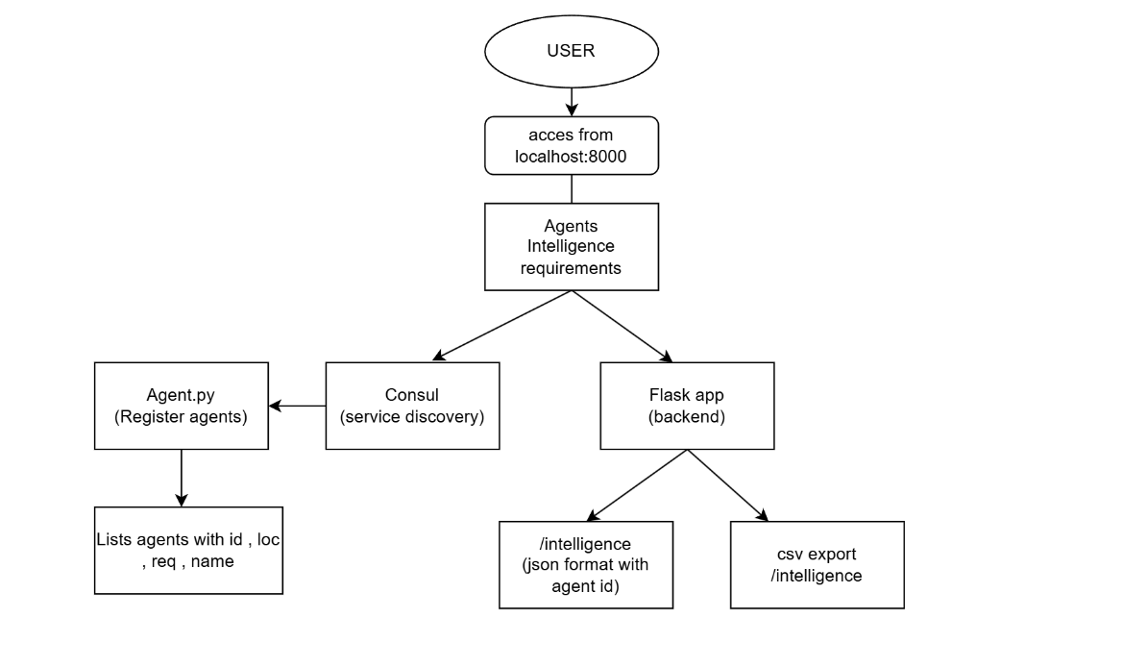

Registration Process of a given agent:-

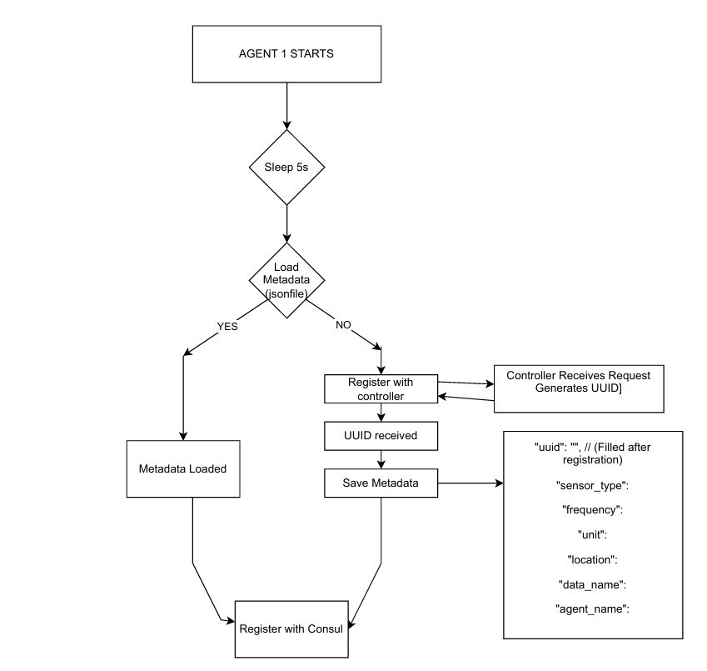

11. Conclusion
This project demonstrates a modular distributed monitoring system using a microservices architecture with Consul for dynamic service discovery. It provides environmental and traffic metrics in a centralized dashboard, proving feasibility for smart city monitoring.
Key accomplishments include:
- Implementation of multiple independent agents, each responsible for generating specific synthetic sensor data (traffic, CO₂, humidity, temperature, noise).
- Dynamic agent registration and health monitoring using Consul, ensuring agents are discoverable and their availability is tracked.
- A central Flask-based dashboard that aggregates and visualizes agent data, enabling operators to monitor system health and export metrics for further analysis.
- Modular architecture that allows individual agents to be scaled or updated independently, improving maintainability and system resilience.
- Clear separation of responsibilities, aligning with best practices in microservices design.
- A self-describing system, where each agent exposes metadata, capabilities, intelligence, and requirements through standardized APIs.
Future improvements could include:
- Integration of real sensor hardware for live data collection.
- Enhanced data analytics, such as trend detection and anomaly alerts.
- Adding authentication and authorization mechanisms for secure agent–controller communication.
- Extending the dashboard with real-time charts and historical data visualization.
- Deploying the system to the cloud or edge devices for production-scale smart city environments.
This project demonstrates a solid foundation for scalable, flexible, and maintainable distributed monitoring systems, essential for next-generation urban management solutions.

